**EXPERIMENT 2**

**By- R2142220816**

**AIM: Working with Docker (Basic Commands)**

**Steps to Complete:**

1. Search a Redis image on DockerHub

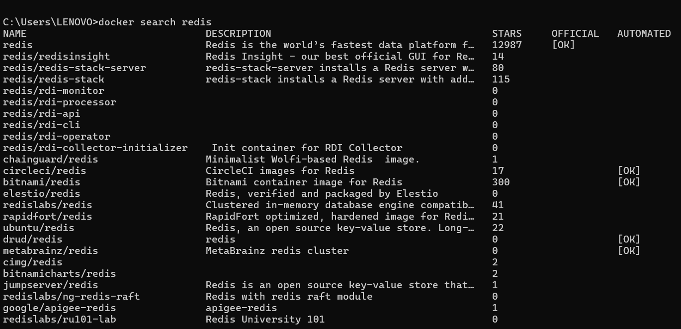

1. Run Docker Container of Redis Image in background

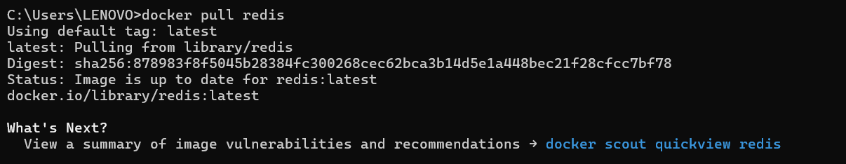



1. Run Docker PS and Docker PS –a





1. Run Docker Container and take its console

